**Reference Guide for Accessing Azure Virtual Desktop**

**User can Access the Virtual Desktop Session Host Machines via Web Browser or through Desktop Application:  
  
1.** Accessing the Session Host via Browser   
 **1.1.** User can create a session under the session Host by accessing the following URL: <https://aka.ms/avdweb> **1.2.** Hitting the URL Firstly you need to Authenticate the User **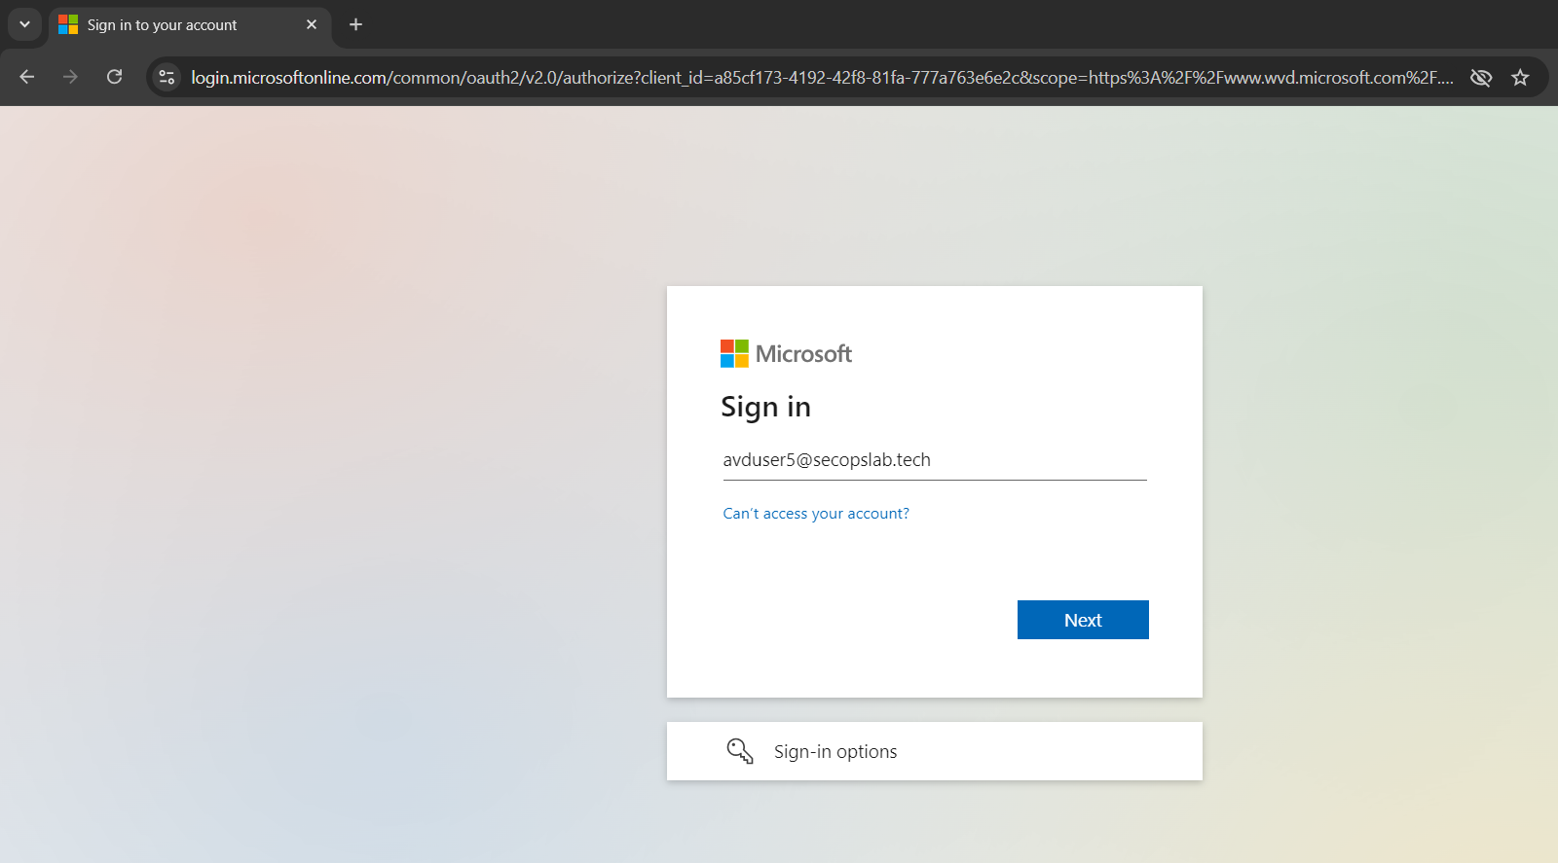  
  
  
  
  
  
  
  
  
  
  
  
1.3.** This is a workspace where users can interact with you. Access the session host by clicking on the Session Desktop icon.  
  
  
1.4**. To connect to the session host application, you need to reauthenticate the user. Once reauthenticated, you will be able to access the session host.  
  
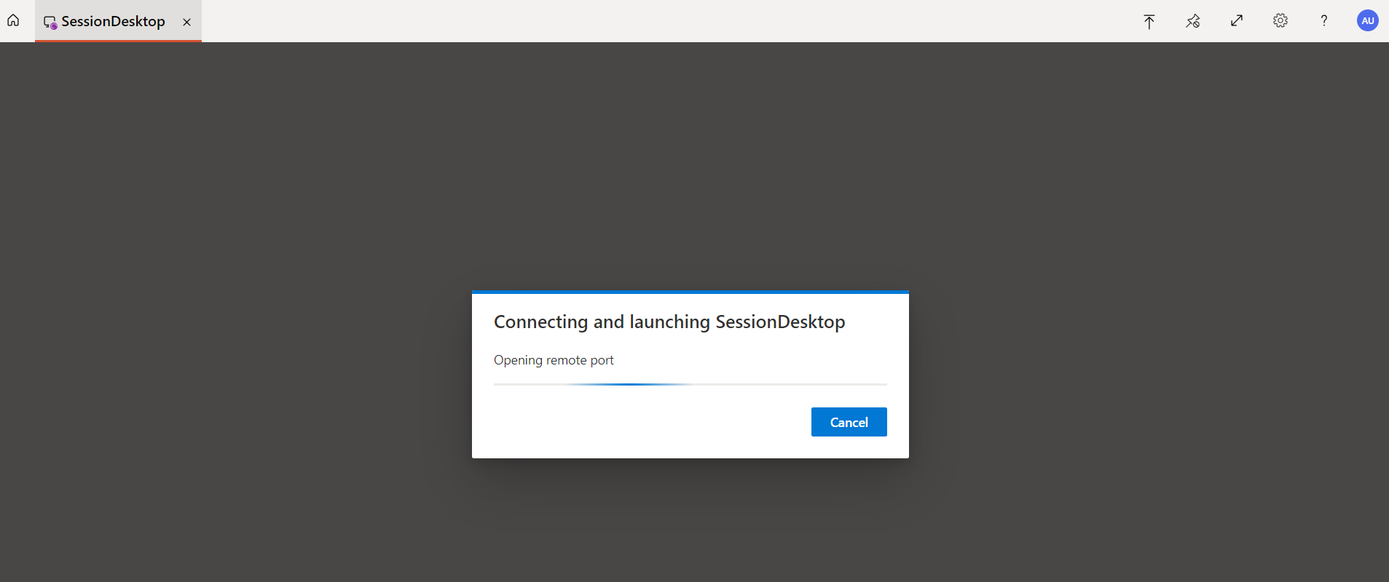  
 **2.** Accessing the Session Host via Desktop Application **2.1.** User can Download the Remote Desktop Application using the following URL: <https://go.microsoft.com/fwlink/?linkid=2139369>   
  
**2.2.** Once the Application is Installed on the Desktop you will prompt the following Screen and need to click on Subscribe to Authenticate the User.  
  
**2.3.** This is a workspace where users can interact with you. Access the session host by clicking on the Session Desktop icon.

**2.4**. To connect to the session host application, you need to reauthenticate the user. Once reauthenticated, you will be able to access the session host.  
  
